

**I/IV-B.Tech-(ODD Sem), Academic Year: 2023-2024**

**B. Tech. (AIDS,CSE,CSIT,ECE), 2023 Batch I/IV, ODD Semester**

**Subject Code: 23MT1002**

**TITLE: Discrete Structures**

**CO-2: CLASSROOM DELIVARY PROBLEMS**

**Session-8**

1. Identify which of the following are sentences or propositions?
2. New Delhi is the capital of India.
3. **for x=2,** x + 7 = 5.
4. x + 3 = 5
5. Did you understand?
6. Let *p* and *q* be the propositions.

*p* : I bought a lottery ticket this week.

*q* : I won the million-dollar jackpot.

Express each of the following propositions in words.

**1)** ￢*p* **2)** *p* ∨ *q* **3)** *p* → *q*

**4)** *p* ∧ *q* **5)** *p* ↔ *q* **6)** ￢*p* →￢*q*

**7)** ￢*p* ∧￢*q* **8)** ￢*p* ∨ *(p* ∧ *q)*

1. Construct the truth tables for the following and verify whether it is a tautology/ contingency/ or not.
   1. [(pVq) Ʌ(~r)] ↔q.
   2. (pV~q) →(pɅq)
2. 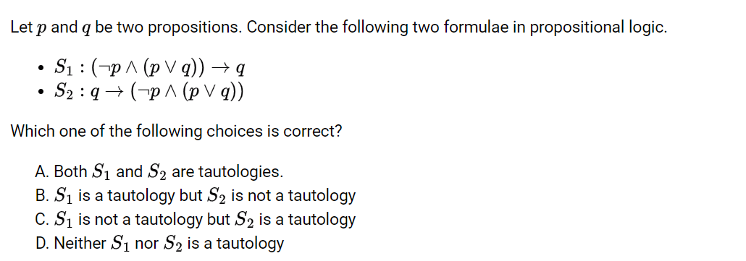

**GATE 2021**

**Session-9**

1. Express the contrapositive, converse and the inverse of the given conditional statement **“The home team wins whenever it is raining”.**
2. Show that ￢(p ∨ q) and ￢p ∧￢q are logically equivalent.
3. Show that p→q ≡ ￢p ∨ q
4. Show that (p → q) ∧ (p → r) and p → (q ∧ r) are logically equivalent.
5. Use a truth table to verify the De Morgan law ￢(p ∧ q) ≡ ￢p ∨￢q.

**Session-10**

1. Determine rɅ(p V q) is a valid argument (valid Conclusion) from the premises H1: pVq, H2: q→r,H3: p→m and H4:~m.
2. Determine whether the conclusion C, follows logically from the premises H1: ~pVq , H2 : ~(qɅ~r) , H3: ~r, C: ~p
3. Use resolution to show the hypotheses “Allen is a bad boy or Hillary is a good girl” and “Allen is a good boy or David is happy” imply the conclusion “Hillary is a good girl or David is happy.”
4. What rules of inference are used in this argument? “No man is an island. Manhattan is an island. Therefore, Manhattan is not a man.” **GATE2019**

**Session-11**

1. Translate these system specifications into English where the predicate *S(x, y)* is “*x* is in state *y*” and where the domain for *x* and *y* consists of all systems and all possible states, respectively.

**a)** ∃*xS(x,* open)

**b)** ∀*x(S(x,* malfunctioning) ∨ *S(x,* diagnostic))

**c)** ∃*xS(x,* open) ∨ ∃*xS(x,* diagnostic)

**d)** ∃*x*￢*S(x,* available)

**e)** ∀*x*￢*S(x,* working)

1. Translate these specifications into English where *F(p)* is “Printer *p* is out of

service,” *B(p)* is “Printer *p* is busy,” *L(j)* is “Print job *j* is lost,” and *Q(j)* is “Print job *j* is queued.”

**a)** ∃*p(F(p)* ∧ *B(p))* → ∃*jL(j)*

**b)** ∀*pB(p)* → ∃*jQ(j)*

**c)** ∃*j (Q(j)* ∧ *L(j))* → ∃*pF(p)*

**d)** *(*∀*pB(p)* ∧ ∀*jQ(j))* → ∃*jL(j)*

1. Express each of these system specifications using predicates, quantifiers, and

logical connectives.

1. When there is less than 30 megabytes free on the hard disk, a warning

message is sent to all users.

1. No directories in the file system can be opened and no files can be closed

when system errors have been detected.

**c)** The file system cannot be backed up if there is a user currently logged on.

**d)** Video on demand can be delivered when there are at least 8 megabytes of

memory available and the connection speed is at least 56 kilobits per

second.

1. Express each of these system specifications using predicates, quantifiers, and

logical connectives.

1. At least one mail message, among the nonempty set of messages, can be

saved if there is a disk with more than 10 kilobytes of free space.

**b)** Whenever there is an active alert, all queued messages are transmitted.

**c)** The diagnostic monitor tracks the status of all systems except the main

console.

1. Each participant on the conference call whom the host of the call did not

put on a special list was billed.

1. Translate into English the statement ∀*x*∀*y((x >* 0*)* ∧ *(y <* 0*)* → *(xy <* 0*)),*

where the domain for both variables consists of all real numbers.

1. Translate the statement “The sum of two positive integers is always positive” into a logical expression.

**Session-12**

1. If n is an even integer then 7n + 4 is an even integer.

2. If m is an even integer and n is an odd integer then m + n is an odd integer.

3. If m is an even integer and n is an odd integer then mn is an even integer.

4. If a, b and c are integers such that a divides b and b divides c then a divides c.

5. Prove that the square of an odd integer is odd.

6. Prove that the square of any even integer is divisible by 4.

**GATE2023**

**Session-13**

1. Explain how you can use an indirect proof by contradiction to prove that there are infinitely many prime numbers.
2. Use an indirect proof by contradiction to prove that the statement "If n is an odd integer, then n^2 is odd" is true.
3. Verify the statement "There is a positive integer n such that n^3 - 5n - 6 = 0" is true using an indirect proof by contradiction.
4. Use an indirect proof by contradiction to prove that the statement "If n is an even integer, then n^2 is even" is true.
5. Prove that the statement "For any two positive integers a and b, if a + b is odd, then a and b cannot both be odd" using an indirect proof by contradiction.
6. Use an indirect proof by contradiction to prove that the statement "If a and b are integers, then a + b is even if and only if a and b have the same parity" is true.